CLOUD COMPUTING
LAB 06



Submitted To:
Engr. Shoaib

Submitted By:
Komal Kashif
BSE V-A
2023-BSE-031

Task 1: Switch to root with su – and back to a normal user
Steps
- Set a root password
sudo passwd root

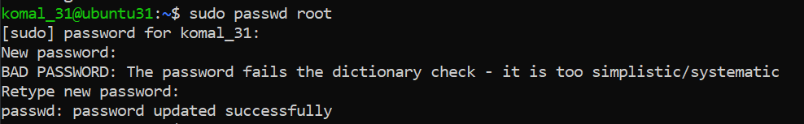
- Switch to the root user and verify:
su –
whoami
id
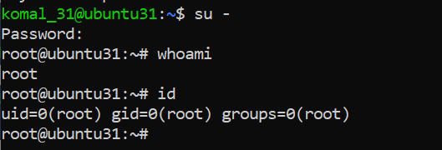

- Switch back to the normal user and verify:
exit
whoami

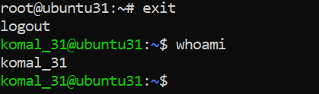

Task 2: Create user tom and verify in passwd/group/shadow
Steps
- Create a new user tom
sudo adduser tom

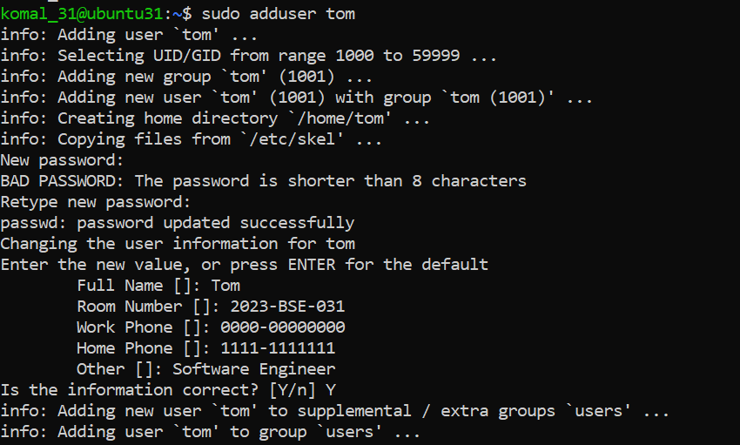
- Verify user tom in the /etc/passwd file:
cat /etc/passwd

- Verify user tom in the /etc/group file:
cat /etc/group

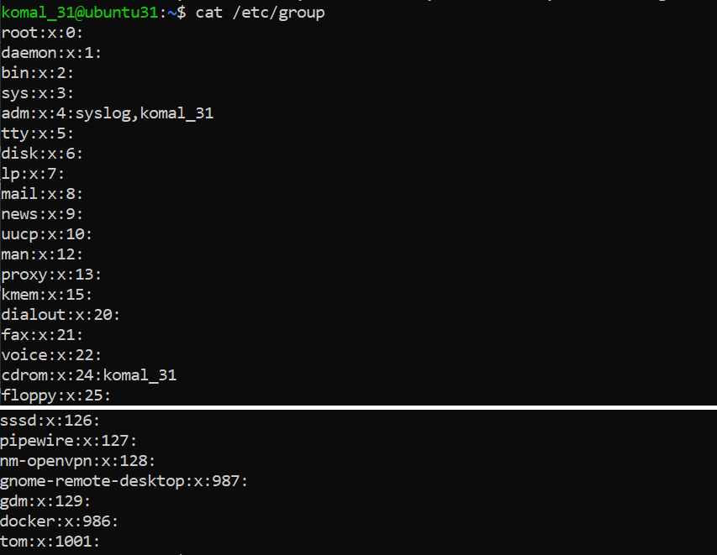

- Verify user tom in the /etc/shadow file:
sudo cat /etc/shadow

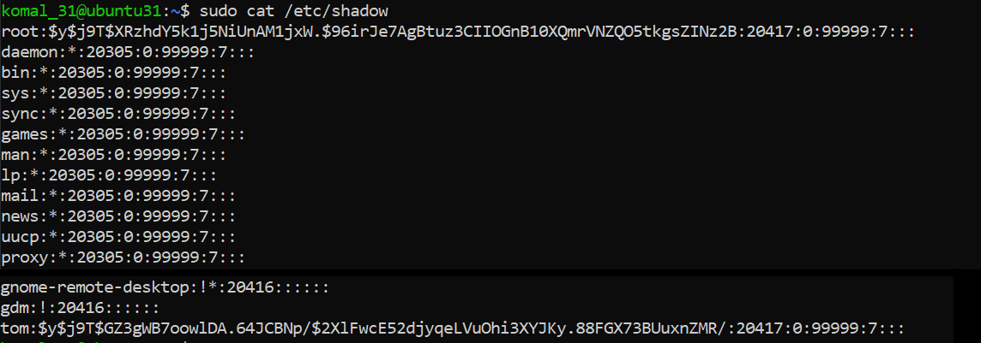

Task 3: Create groups; change tom’s primary and secondary groups
Steps
- Create the required groups and verify:
sudo groupadd developer
sudo groupadd devops
sudo groupadd designer
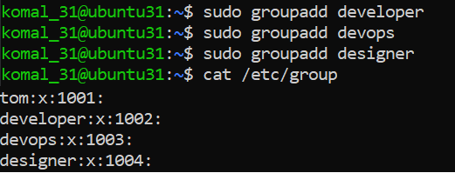

- Change tom’s primary group to designer and verify:
sudo usermod -g designer tom
id tom
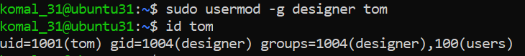

- Add secondary groups developer and devops to tom and verify:
sudo usermod -aG developer,devops tom
id tom
groups tom

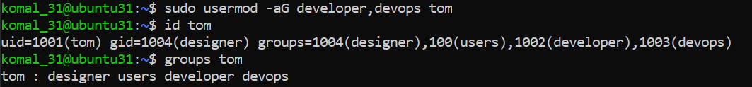

- Reset secondary groups so only tom (user’s own group) remains and verify:
sudo usermod -G tom tom
id tom
groups tom

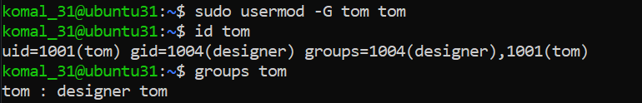

Task 4: Create/Delete Users (Jerry, Scooby) and Groups (jolly, anime)
Steps
- Create new users Jerry and Scooby:
sudo adduser Jerry
sudo useradd Scooby

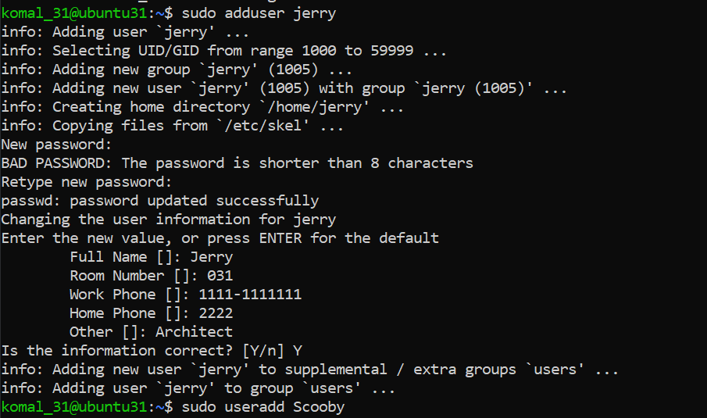

  - adduser automatically created a home directory and prompted for a password.
  - useradd created a basic user account without a home directory or password.

- Attempt to log in as Scooby before setting a password (expected failure):
su – Scooby

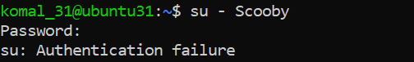

- Set a password for Scooby:
sudo passwd Scooby

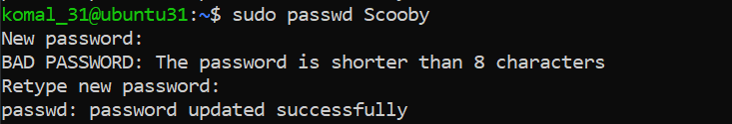

- Log in again as Scooby (observe missing home directory warning):
su – Scooby

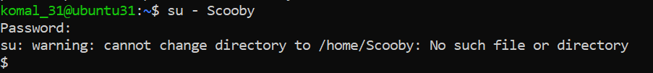

- Verify Scooby’s home directory and /etc/passwd entry:
cat /etc/passwd

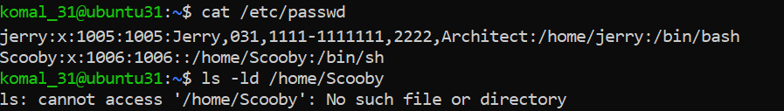

- Manually create Scooby’s home directory and set ownership/permissions:
sudo mkdir -p /home/Scooby
sudo chown Scooby:Scooby /home/Scooby
sudo chmod 750 /home/Scooby
ls -ld /home/Scooby

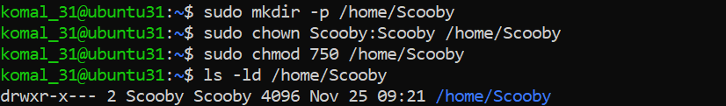

- Log in as Scooby again to confirm correct home directory access:
su - Scooby
pwd
ls -la

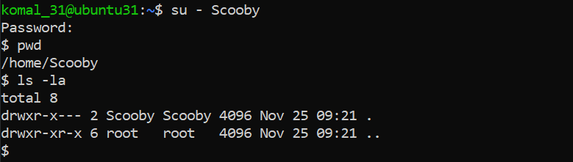

- Verify users in /etc/passwd and check Scooby’s shell:
cat /etc/passwd

- Create groups jolly and anime:
sudo addgroup jolly
sudo groupadd anime

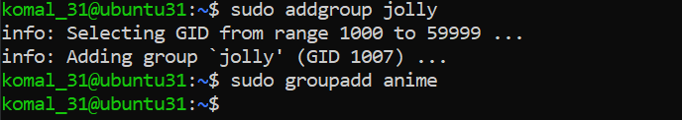
- Verify groups in /etc/group:
cat /etc/group

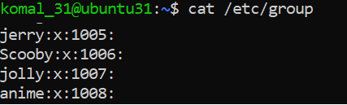

- Delete the groups and users:
sudo delgroup jolly
sudo groupdel anime
cat /etc/group

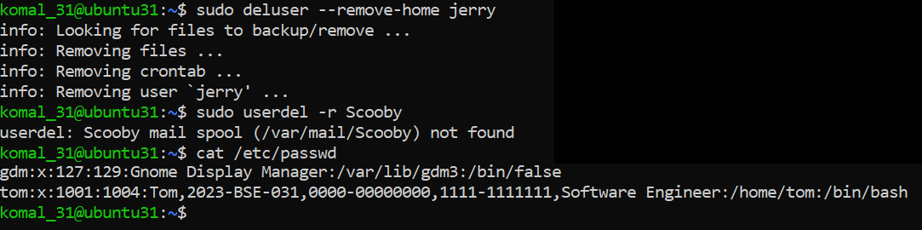

sudo deluser --remove-home Jerry
sudo userdel -r Scooby
cat /etc/passwd

Task 5: Create User “Student”; Create Files; Set Owner/Group; Identify File Types
Steps
- Create a new user Student:
sudo adduser Student

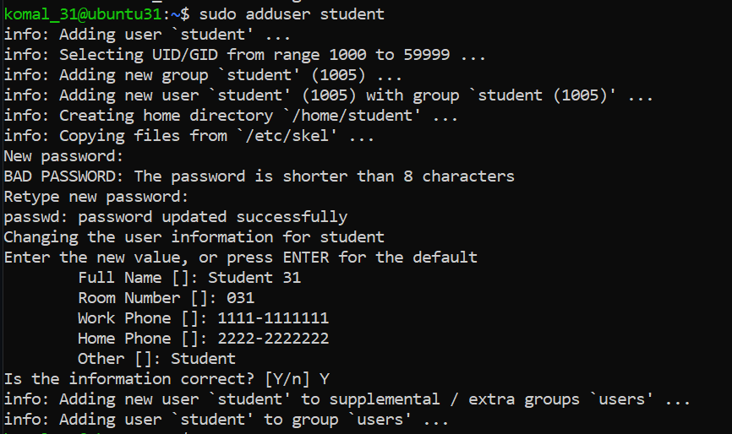

- Switch to Student and create files and directories:
su - Student
touch file1
mkdir -p dir1
touch dir1/file2
ls -l

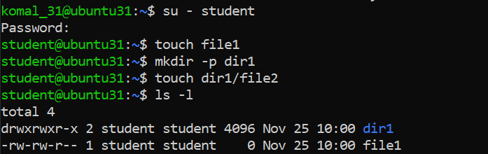

- Change the owner of file1 to tom and verify:
sudo chown tom file1
ls -l file1

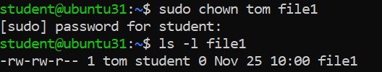

Change the group of file1 to devops and verify:
sudo chgrp devops file1
ls -l file1

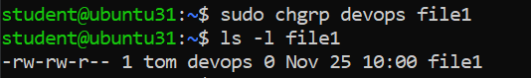
- Identify files, directories, and special files:
ls -l
ls -l dir1
ls -l /dev/null
file file1 dir1 /dev/null

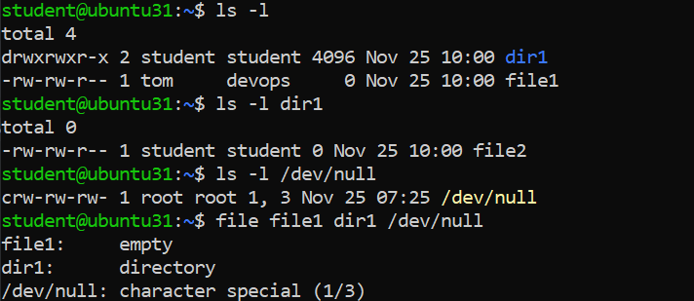

- Exit from Student account:

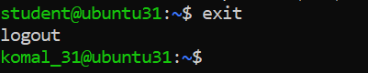

Task 6: Change Permissions Using Symbolic Mode
Steps:
- Ensure the Student user and target file exist:
su - Student
cd ~
ls -l file1

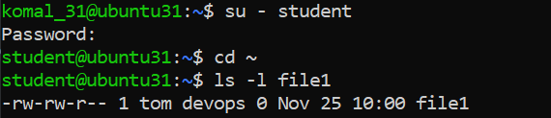

- Remove all permissions from file1:
chmod -rwx file1
ls -l file1

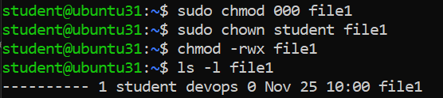

- Add read permission to all users:
chmod +r file1
ls -l file1
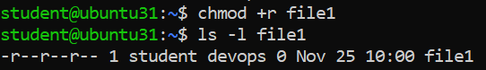
- Add execute permission to the user (owner):
chmod u+x file1
ls -l file1

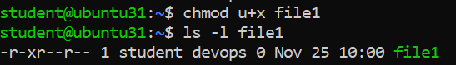

- Add write permission to both user and group:
chmod ug+w file1
ls -l file1

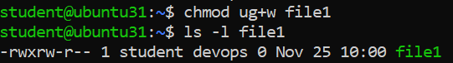

- Remove all permissions explicitly from user, group, and others:
chmod ugo-rwx file1
ls -l file1

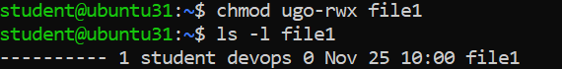

Task 7: Change Permissions Using “Set” Symbolic Form (u= g= o=)
Steps
- Ensure you are logged in as Student and confirm the file exists:
su - Student
cd ~
ls -l file1

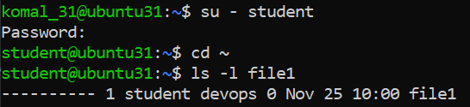

- Set all permissions (read, write, execute) for user, group, and others:
chmod u=rwx,g=rwx,o=rwx file1
ls -l file1

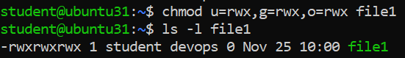

- Remove execute permission from group and others:
chmod g=rw,o=rw file1
ls -l file1

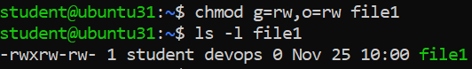
- Remove all permissions from user, group, and others:
chmod u=,g=,o= file1
ls -l file1

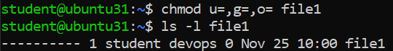

Task 8: Change Permissions Using Numeric (Octal) Mode
Steps
- Ensure you are logged in as Student and the file exists:
su - Student
cd ~
ls -l file1

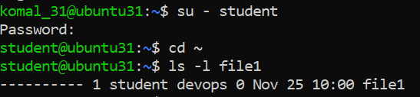

- Set permissions to 777 (rwx for user, group, and others):
chmod 777 file1
ls -l file1

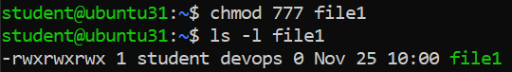

- Set permissions to 700 (rwx for user only):
chmod 700 file1
ls -l file1

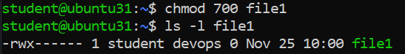

- Set permissions to 744 (rwx for user, read for group and others):
chmod 744 file1
ls -l file1

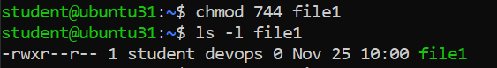

- Set permissions to 640 (rw for user, r for group, none for others):
chmod 640 file1
ls -l file1

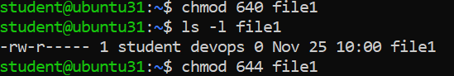
- Set permissions to 664 (rw for user and group, read for others):
chmod 664 file1
ls -l file1

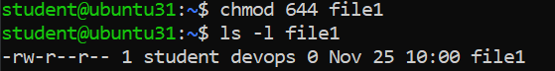

- Set permissions to 775 (rwx for user and group, read/execute for others):
chmod 775 file1
ls -l file1

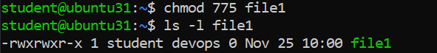

- Set permissions to 750 (rwx for user, read/execute for group, none for others):
chmod 750 file1
ls -l file1

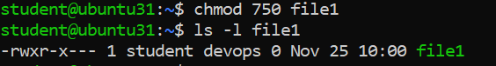

Task 9: Practice Pipes, Pagers, Grep, and Redirects with
Steps
- View /var/log/syslog using less (with pipe):
sudo cat /var/log/syslog | less

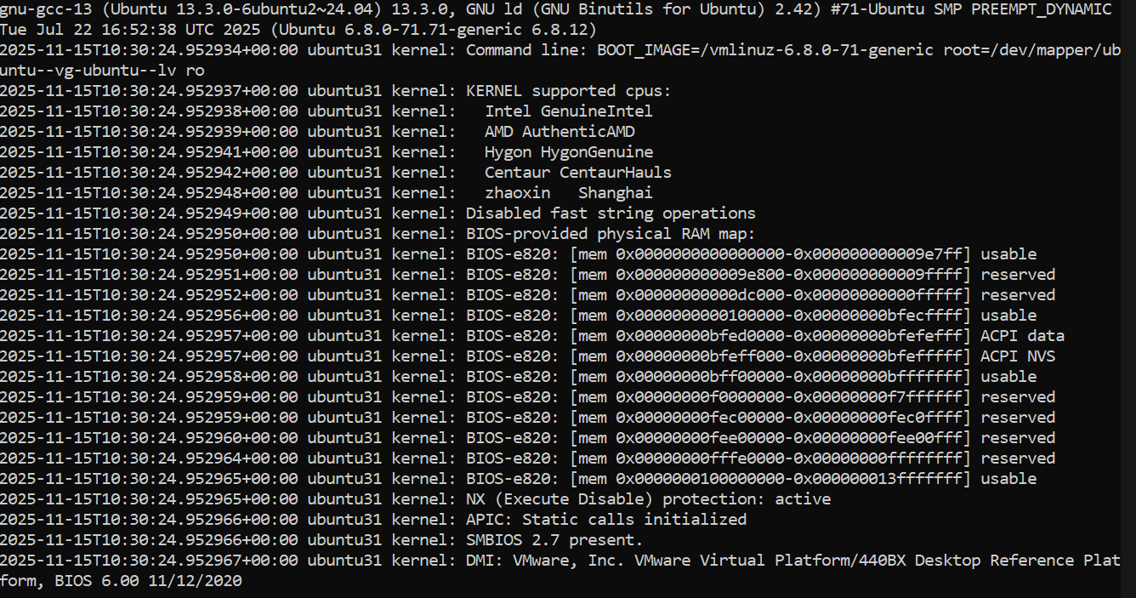

- View /var/log/syslog using more (with pipe):
sudo cat /var/log/syslog | more

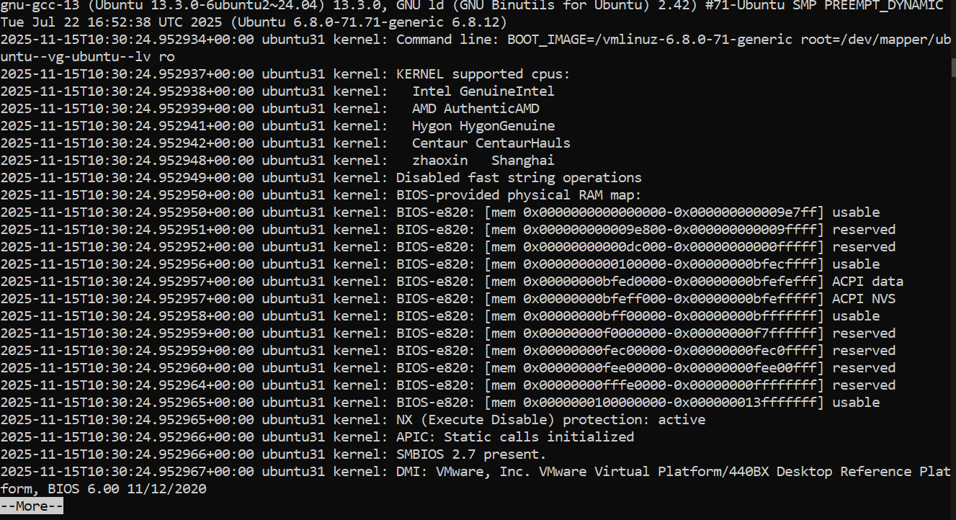

- Search for log entries containing “fail” or “error”:
sudo grep -E 'fail|error' /var/log/syslog | head

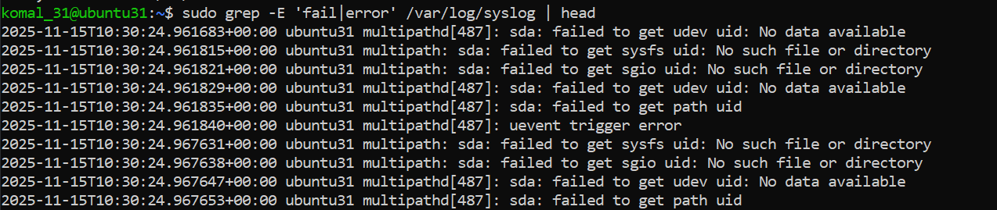

- Redirect search results to a new file (overwrite mode):
sudo grep -i systemd /var/log/syslog > ~/syslog_systemd.txt

- Append additional search results to the same file:
sudo grep -i network /var/log/syslog >> ~/syslog_systemd.txt
cat ~/syslog_systemd.txt

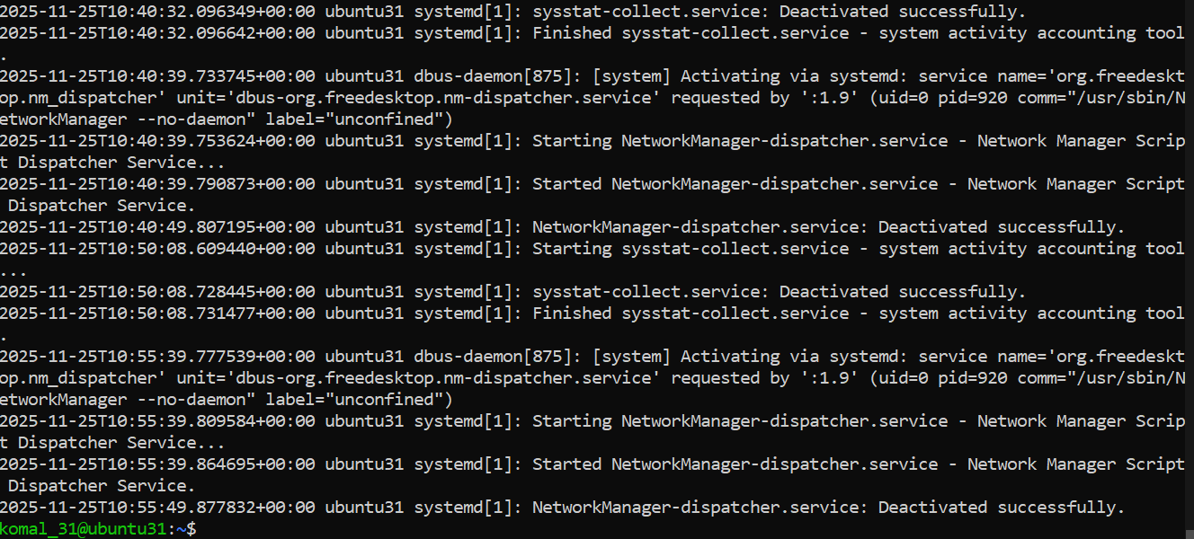

- (Alternative) Use journalctl to explore logs:
sudo journalctl | less
sudo journalctl -u systemd | grep -i error > ~/journal_errors.txt

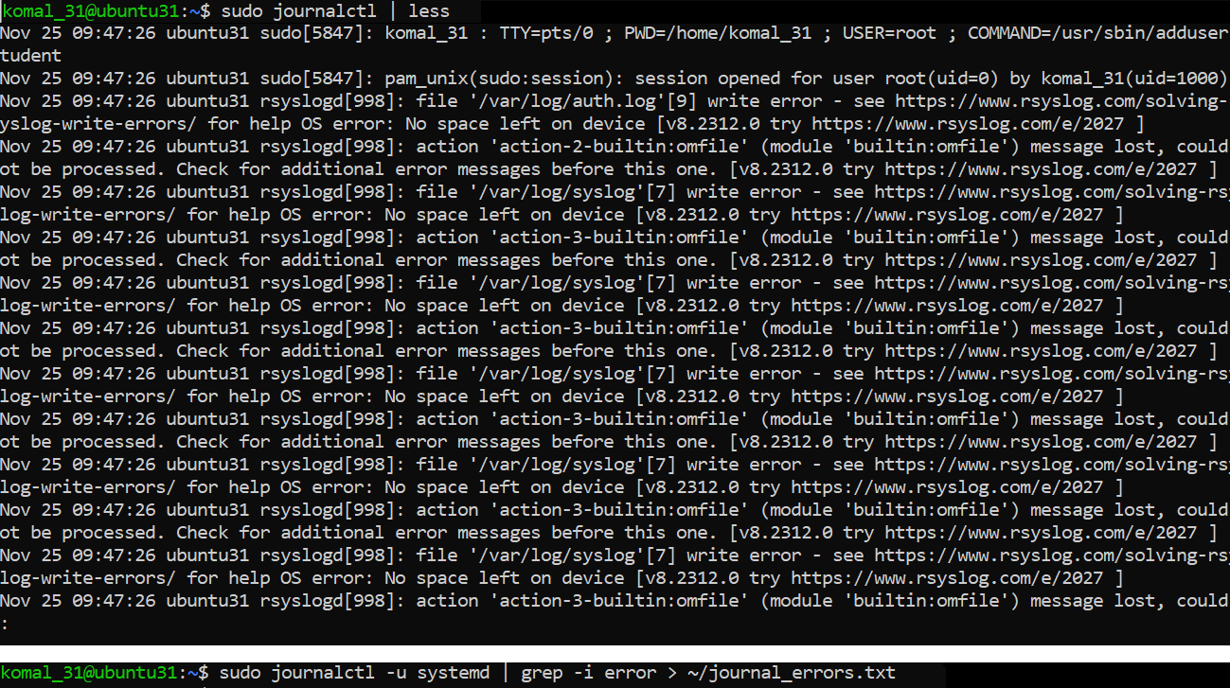

Task 10: Bash Script: setup.sh (Variables, Command Substitution, File/Dir Checks, Permissions)
- Add Bash Shebang
Code added:
#!/bin/bash
- Opened vim: vim setup.sh
- Inserted the shebang line, saved and quit (:wq).
- Made the script executable and ran it:
chmod +x setup.sh
./setup.sh

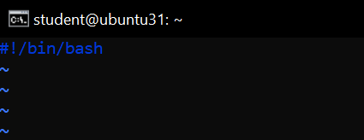

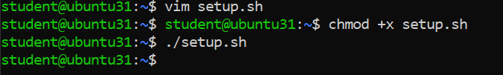

- Define and Display a Variable

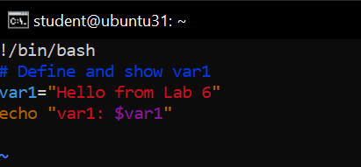

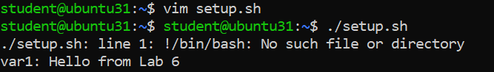

- Command Substitution: Save and Display ls -l

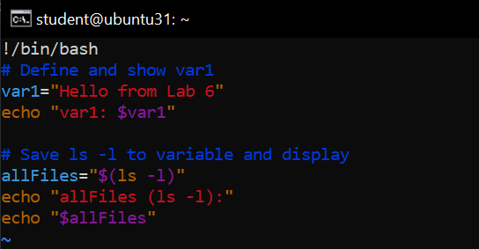

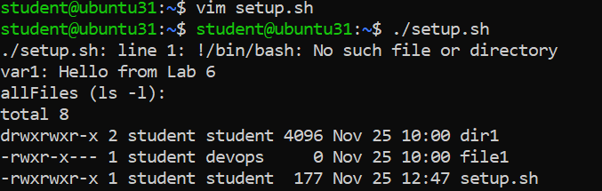
- Directory Check and Creation

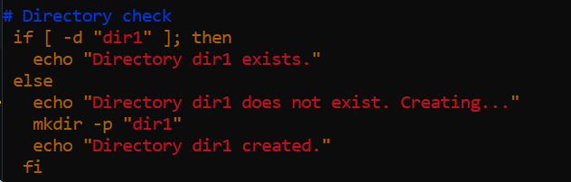

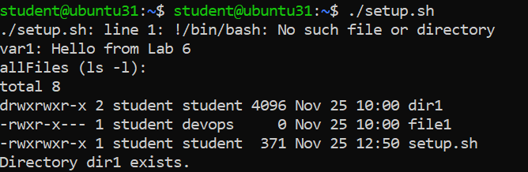

- File Check and Creation

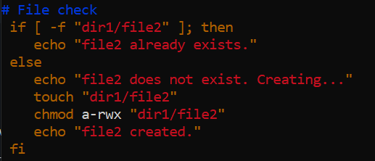

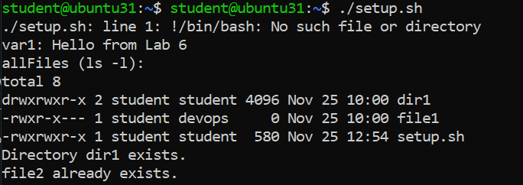

- Permission Check and Adjustment

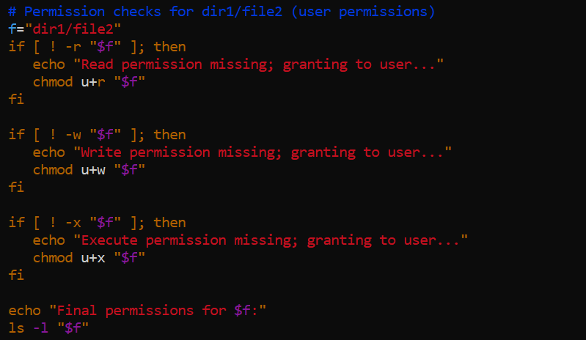

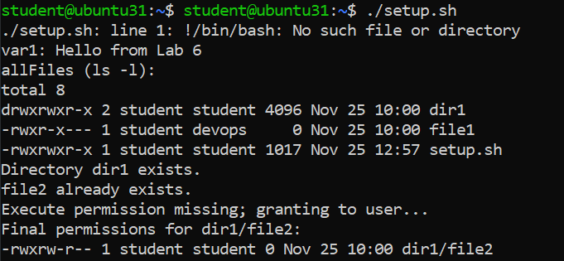

Task 11: Script setup.sh – Argument Comparisons and String Checks
  - Shebang, Variable Setup

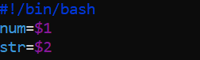

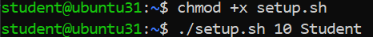

- Numeric Equal ( -eq )

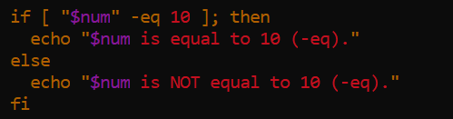

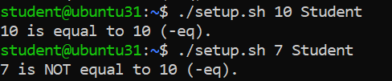

- Numeric Not Equal ( -ne )

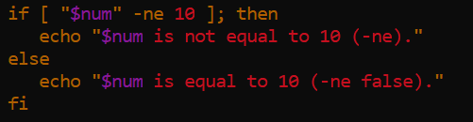

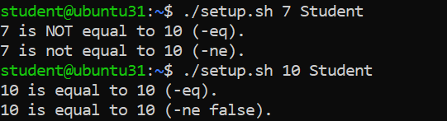

- Greater Than ( -gt )

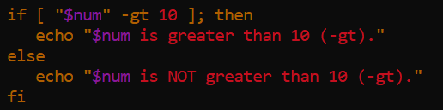

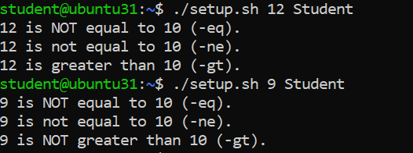

- Less Than ( -lt )

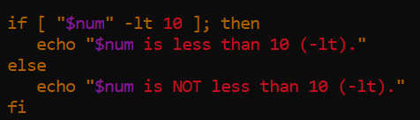

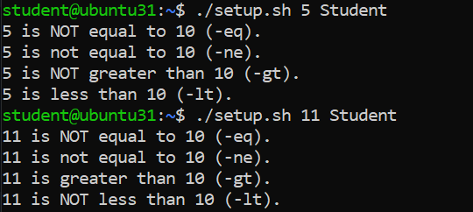

- Greater Than or Equal ( -ge )

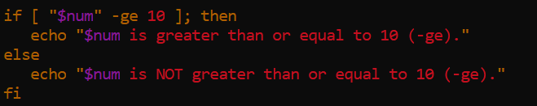

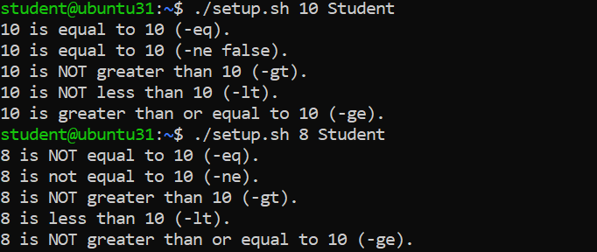

- Less Than or Equal ( -le )

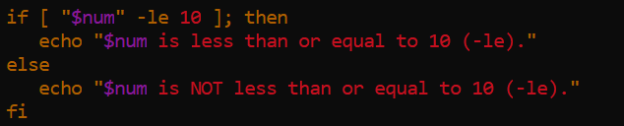

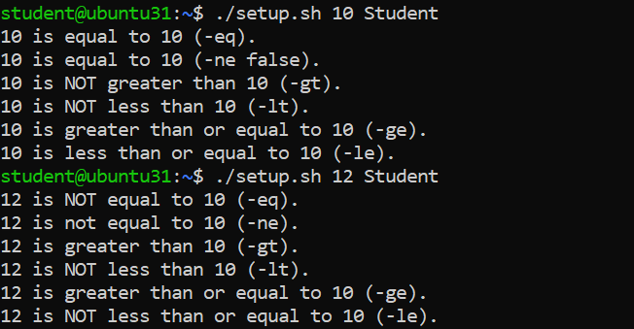

- String Equality ( = )

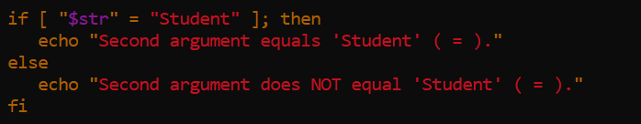

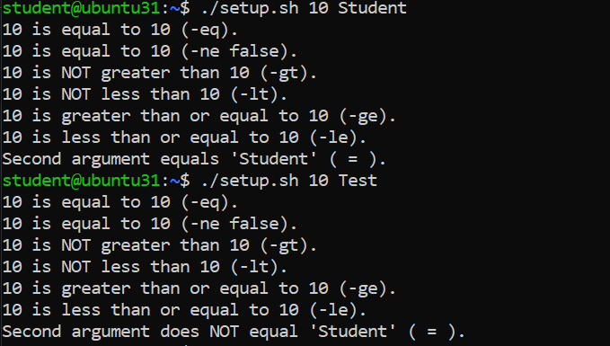

- String Inequality ( != )

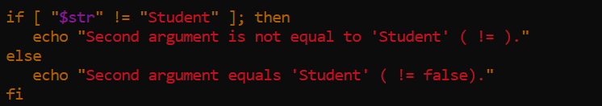

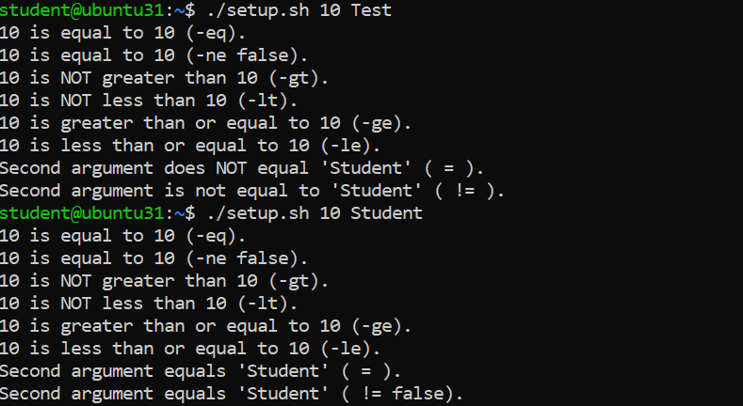

- String Zero-Length ( -z )

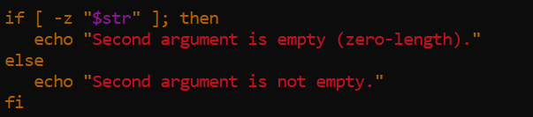

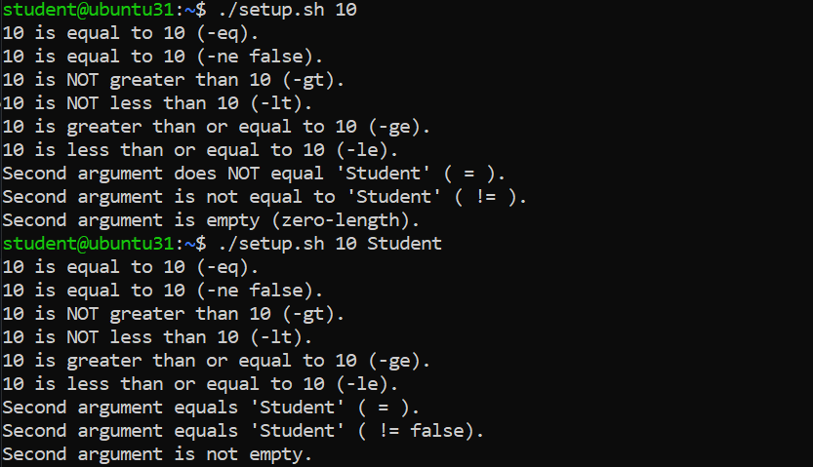

Task 12: Script setup.sh – Print All Arguments with a For Loop

- Shebang and Comment

- Append the For Loop Using $*

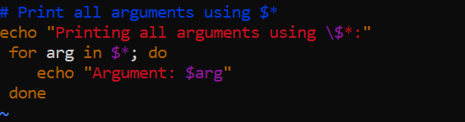

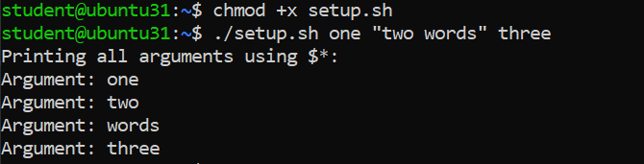

Task 13: Script setup.sh – While Loop Summation and Functions
- Shebang Line

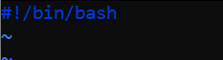

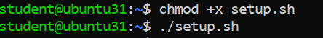

- Interactive While Loop Summation

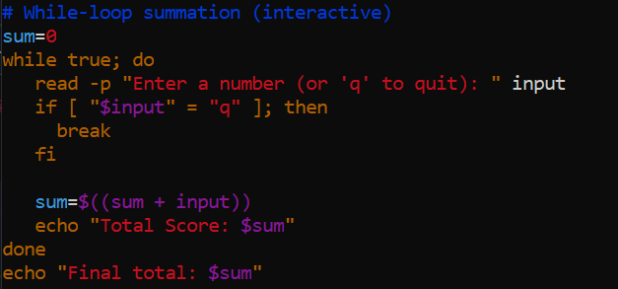

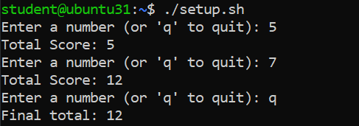

- Function sum_two() (Interactive Loop Inside a Function)

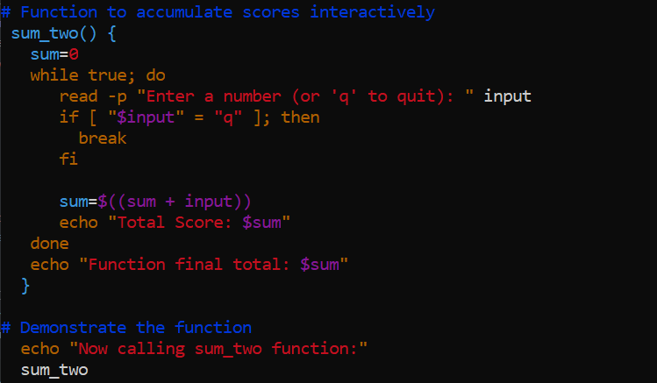

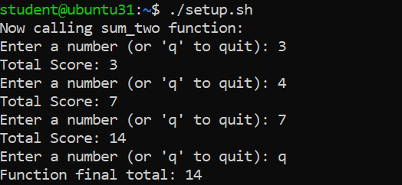

- Function sum_args() (Two Arguments Summation)

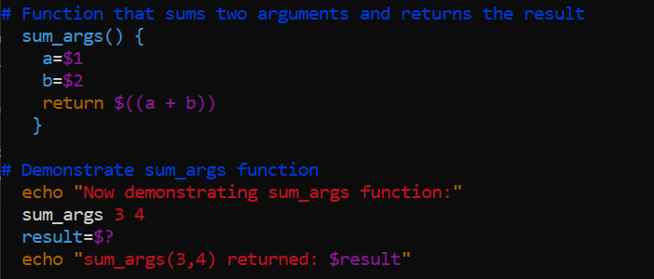

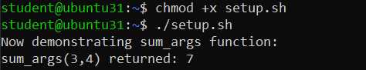

Task 14: Codespaces GUI: Fork Repo, Start GUI, Connect via VNC, Stop GUI

- Fork the repository to your GitHub account
  - Open the repo URL in your browser.
https://github.com/WaqasSaleem97/UbuntuMachine
  - Click Fork (top-right) and fork to your account.

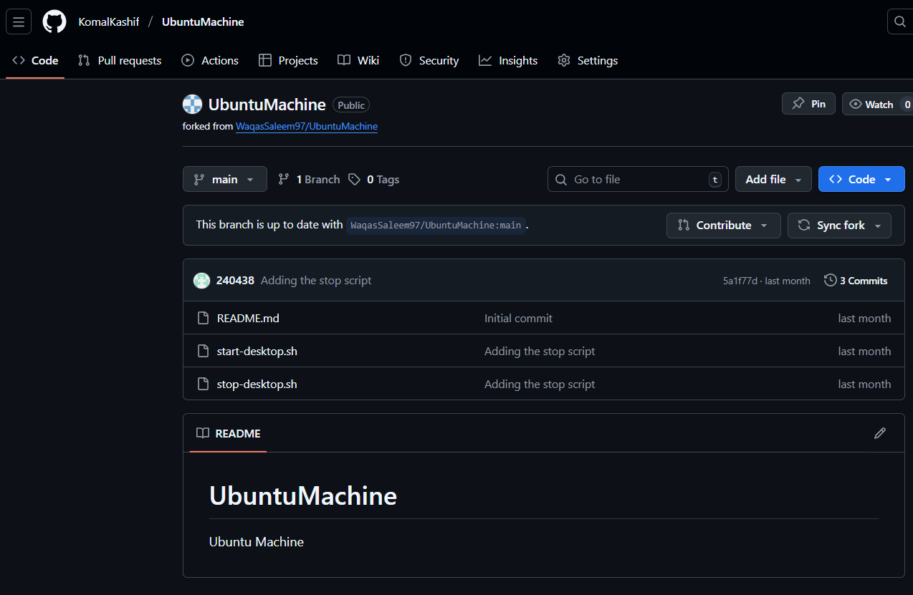

- Open a Codespace on your fork

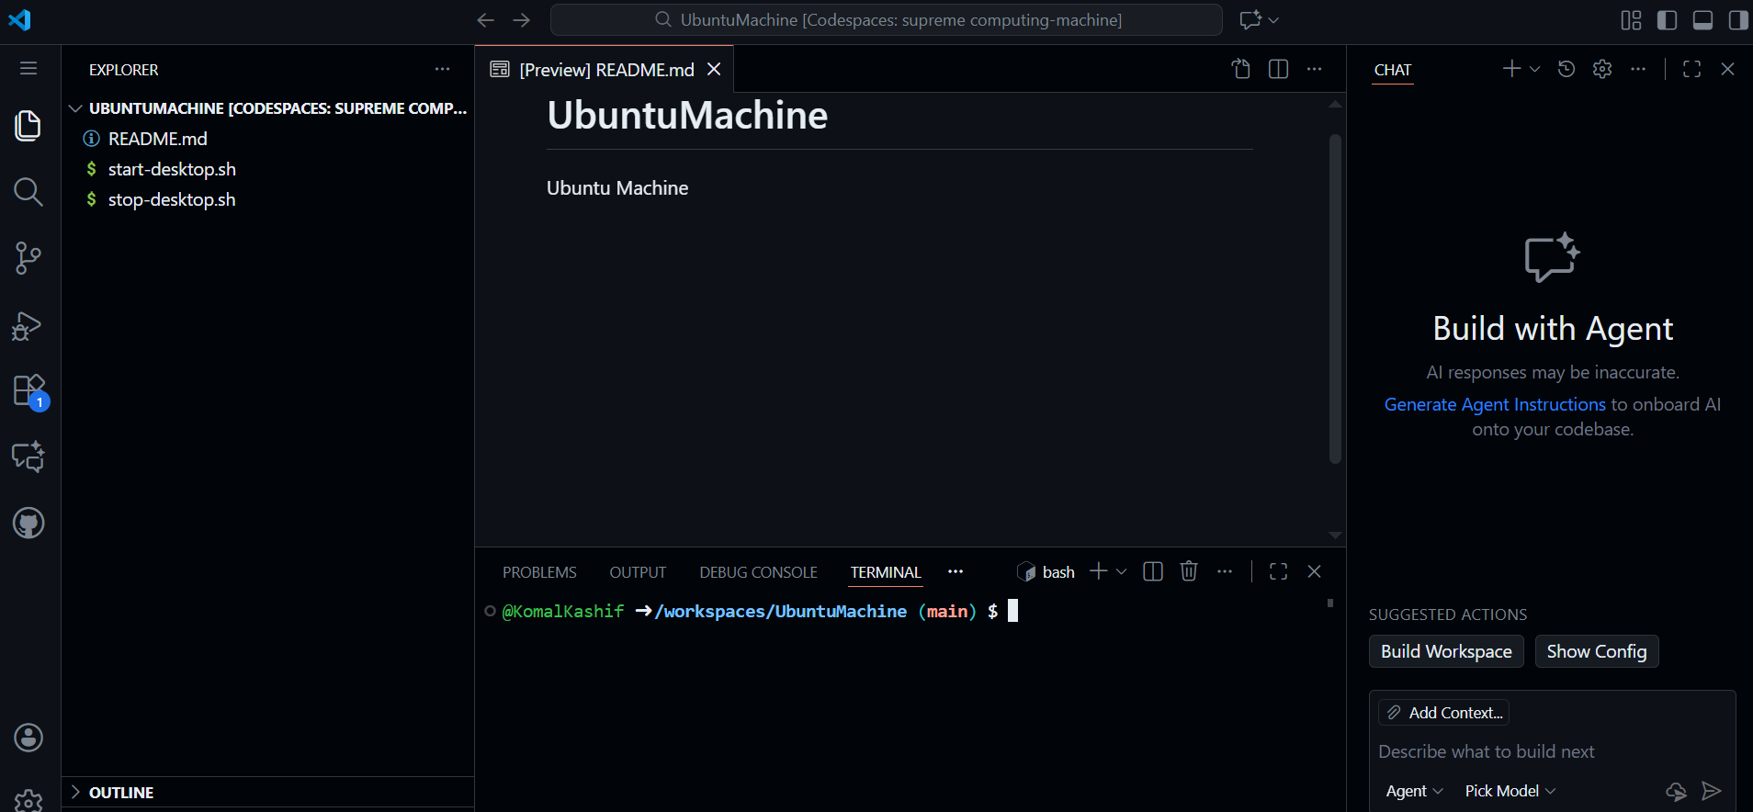

- Verify start/stop scripts exist and are executable
ls -l start-desktop.sh stop-desktop.sh

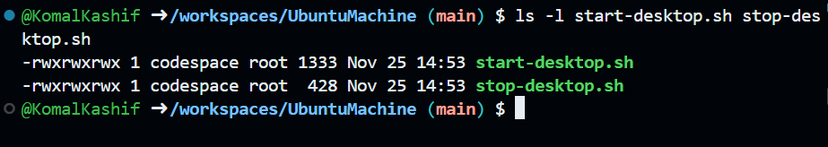

- Run the start script to launch the GUI
./start-desktop.sh
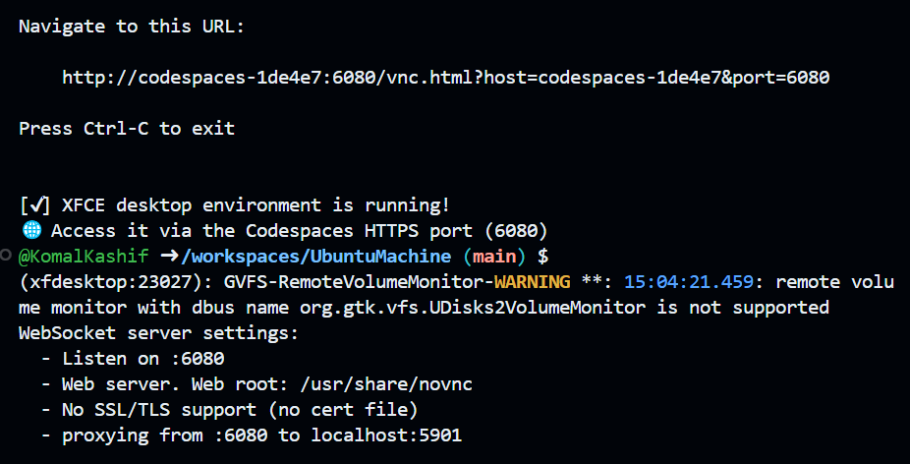

- Verify forwarded ports in Codespaces (Ports view)
  - Open Ports panel and confirm port 6080 is forwarded.

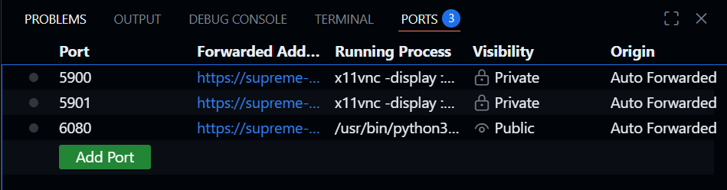

- Connect to the VNC HTML page

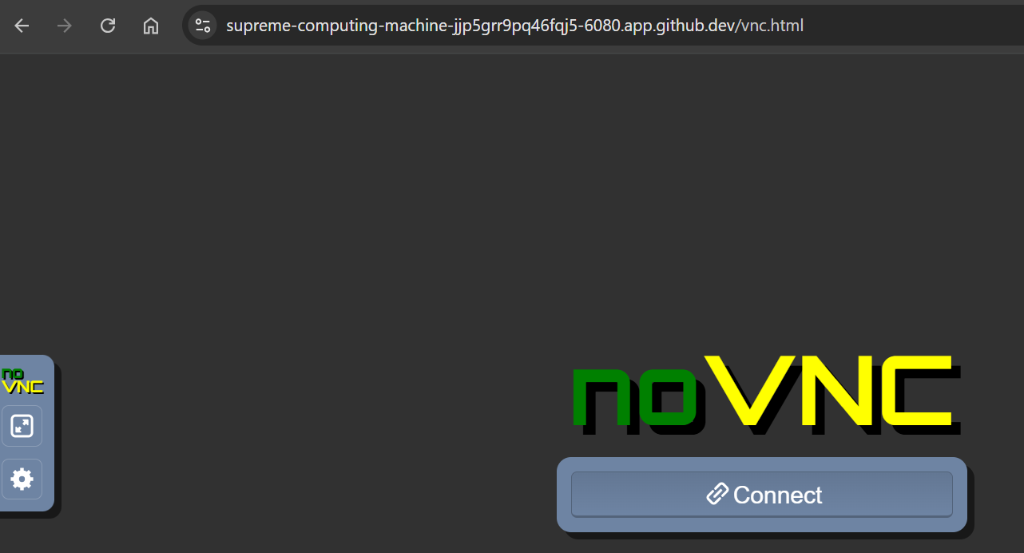

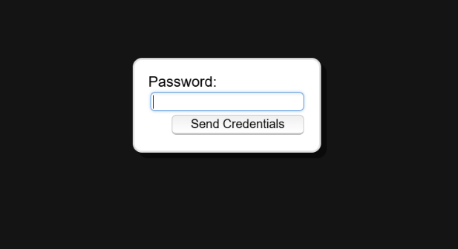

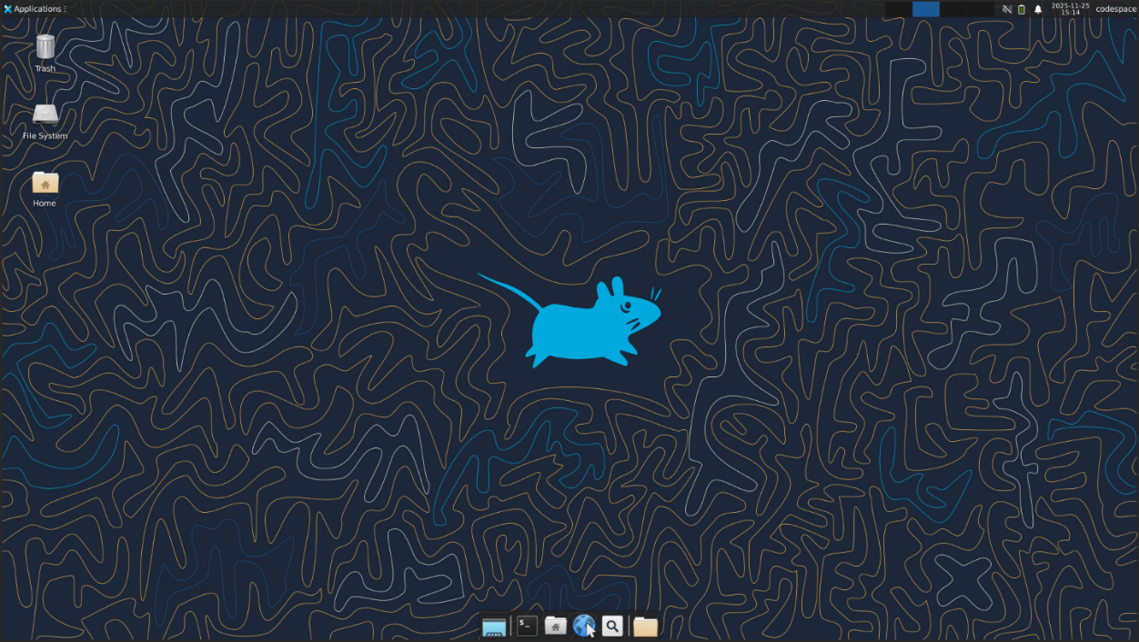

- Stop the GUI
./stop-desktop.sh

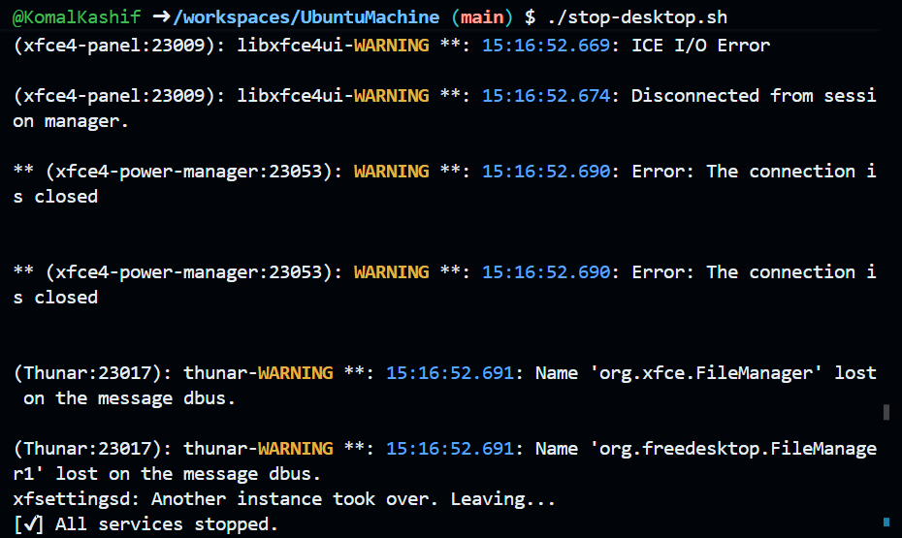

Exam Evaluation Questions

- Group Management and Membership
Scenario: Create groups and manage a user’s primary and supplementary group memberships.
- Create groups g1, g2, and g3
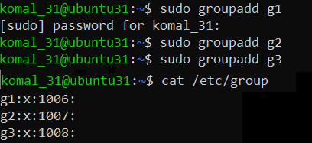

- Change examuser’s primary group and add supplementary groups
  - Primary: g3
  - Supplementary: g1, g2
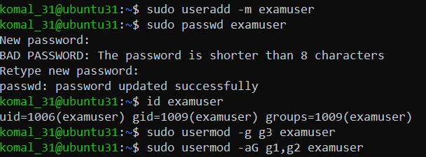

- Verify group changes
  - Show id examuser and relevant /etc/group lines

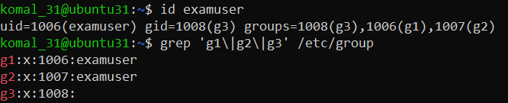

- Ownership and Permission Tasks
Scenario: Demonstrate ownership changes and apply symbolic and numeric permission changes.
- Create file and change ownership

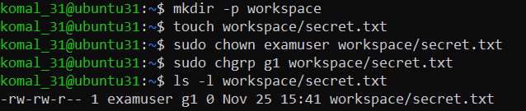

- Remove group/other permissions
  - Symbolic: chmod go-rwx workspace/secret.txt
  - Numeric: chmod 700 workspace/secret.txt

- Show final permissions
ls -l workspace/secret.txt

3. Pipes, Grep, and Redirection Practice
Scenario: Filter system logs and save results using redirection and piping.
- Grep for “error” or “fail” and show first 20 lines
grep -E 'error|fail' /var/log/syslog | head -n 20

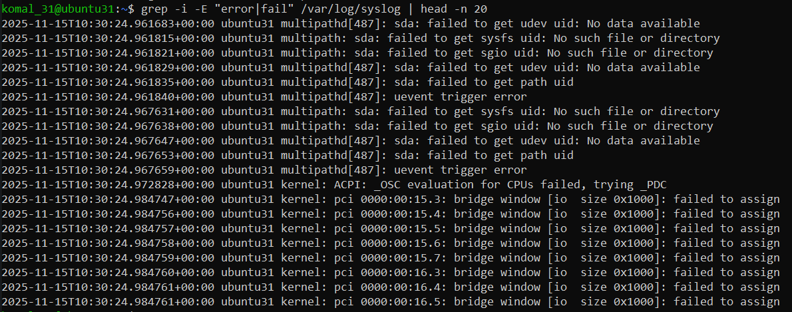

- Save filtered results to a file
grep -E 'error|fail' /var/log/syslog > ~/logs/errors.txt
grep -E 'warning|fail' /var/log/syslog >> ~/logs/errors.txt

- View the saved file using a pager
less ~/logs/errors.txt
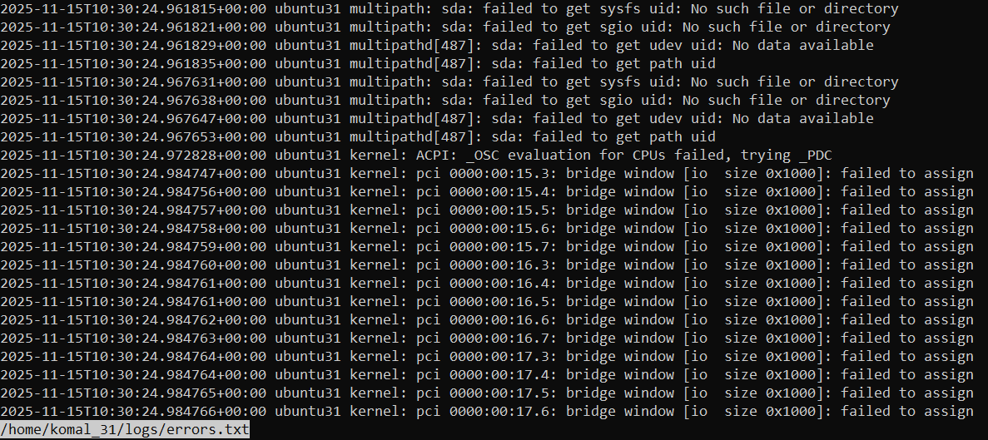

4. Script: Variables, Command Substitution, File & Dir Checks
Scenario: Build and run a script incrementally demonstrating variables, command substitution, and filesystem checks.
- Create setup.sh with shebang and variable var1

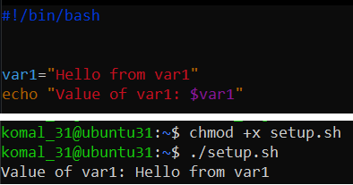

- Append command substitution storing ls -l output

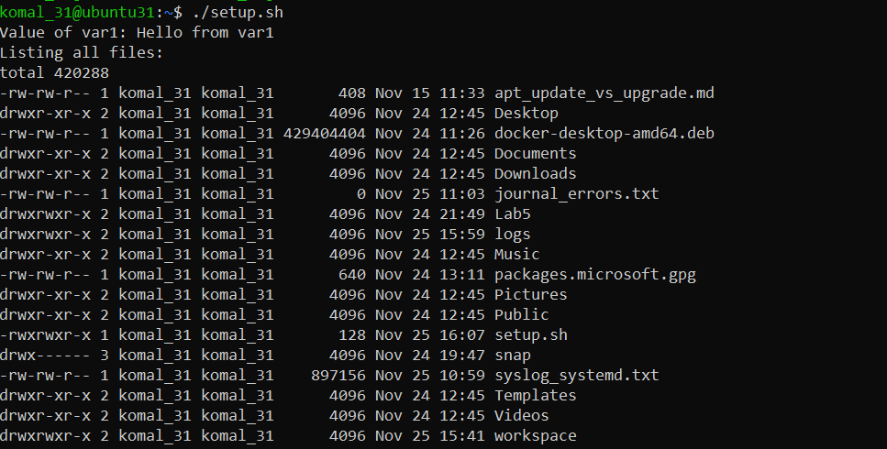

- Append directory/file checks for dir1 and dir1/file2

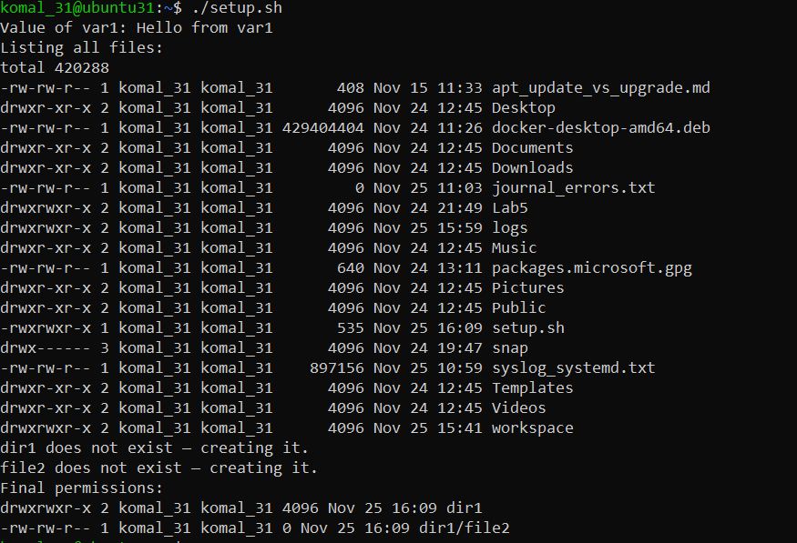

5. Script: Comparisons and String Tests
Scenario: Incrementally add numeric and string comparison tests and show both true/false cases.
- Overwrite setup.sh to set num=$1 and str=$2; add -eq test

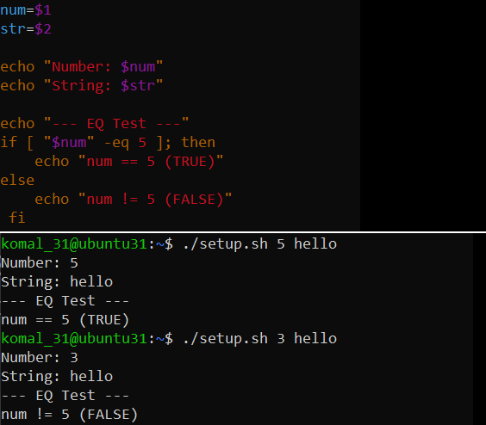

- Append numeric tests: -ne, -gt, -lt, -ge, -l

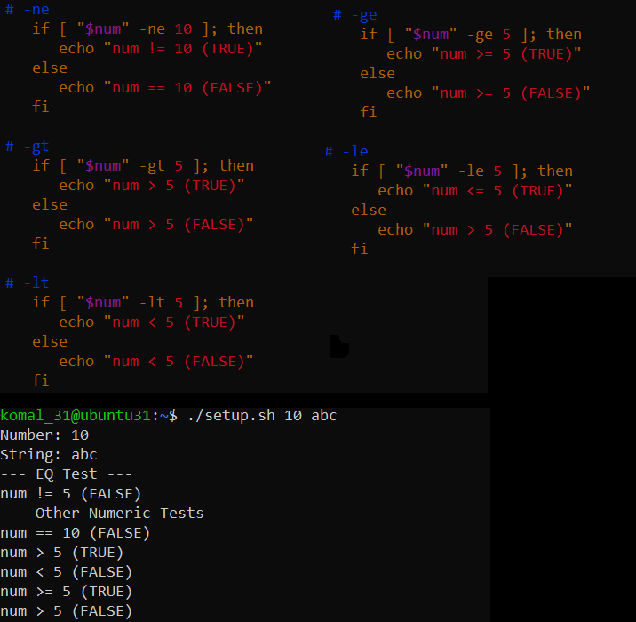

- Append string tests: equality (=), inequality (!=), zero-length (-z)

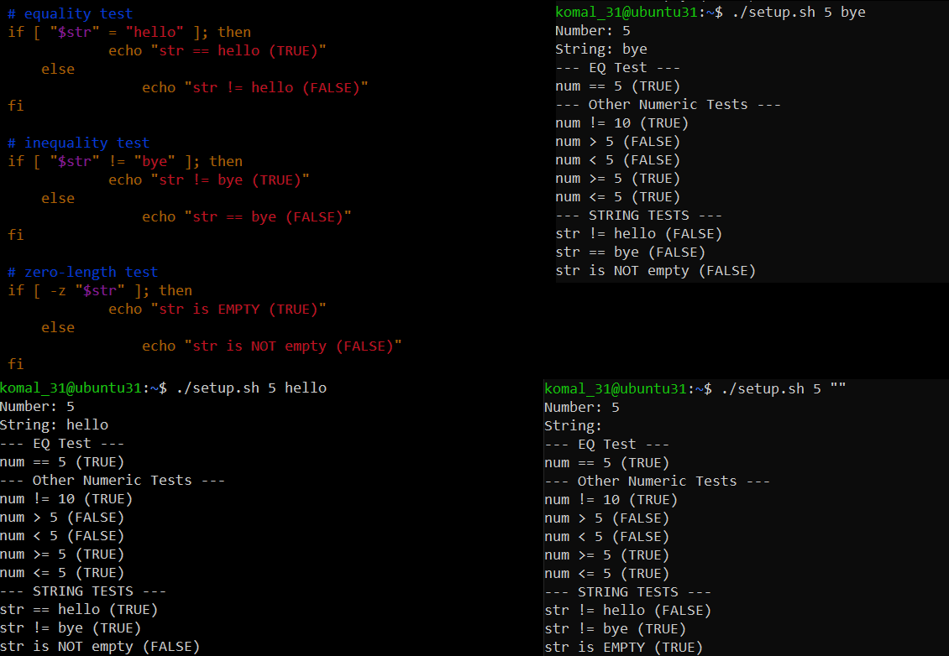

6. Script: For Loop and Argument Handling
Scenario: Print all provided arguments and demonstrate correct handling of quoted multi-word arguments.
- Create/overwrite setup.sh and print each argument using a for loop

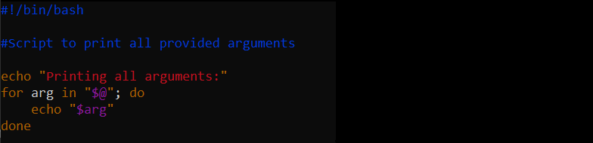

2.Run script with single and quoted multi-word arguments
./setup.sh one "two words" three

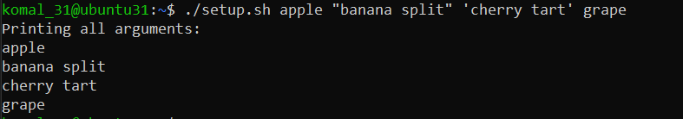

7. Script: While Loop Summation and Functions
Scenario: Implement an interactive summation function and a function returning a numeric result.
- Interactive while-loop that accumulates numbers until q

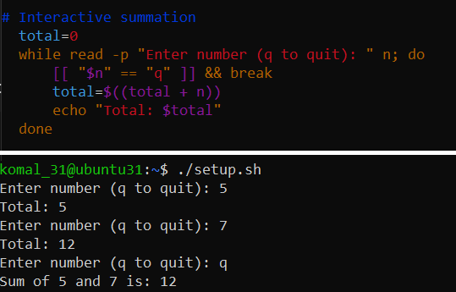

- Function that sums two numeric arguments and demonstrates capturing the result

